**Approach Document for “Four Tile Template”**

Table of Contents

1. *Introduction:* 3

*2. Task Description: 4*

*3. UI Implementation : 4*

*4. Business Logic Implementation: 5*

*5. App changes: 5*

6. *App Server changes:* 5

7. *Web Server changes:* 5

8. *Database changes:* 5

9. *Impacted Items List:* 6

10. *Questions/Clarifications:* 6

11. *Assumptions/Dependencies/Constraints:* 7

12. *Requirement Traceability Matrix* 7

# *Introduction:*

This is the technical document which contains the details about the task and approach to implement the same in details. This document would help the team for any future reference for developing and testing.

The approach document will be prepared for all the tasks other than tasks which needs be addressed in customer priority or during production release.

All developers would be preparing this document and get it validated from Technical lead before starts the implementation.

# *2.Task Description:*

Four tile template should be able to be used for a home page or an internal page. The template needs to be configurable, where user can select the following:

* Number of buttons on the page
* Image on the button
* Tile color and Label color

On click of Buttons, it can lead to either a sub-menu, HTML link, video link, PDF page, news feed page.

* 4 buttons(with customized image) will be displayed vertically one below the other, if a main menu/sub menu has more than 4 buttons then it scrolls vertically.
* A tile on each of the button at the bottom is displayed with customized background color.
* Label at the left corner of the tile is optional.

# 

# *3.UI Implementation :*

iPhone /Android iPad

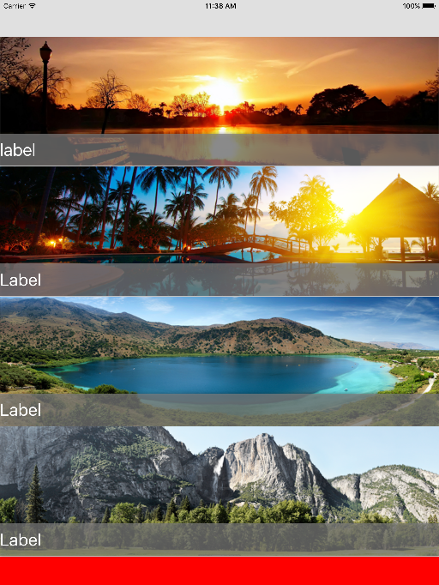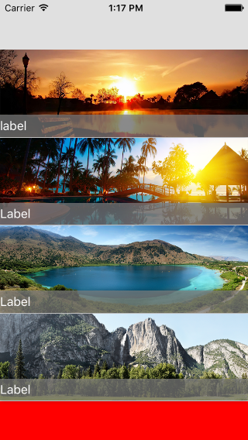

# 

# *3.Business Logic Implementation:*

**iOS /Android:**

* Here, menu is displayed with optional bottom bar.
* By default 4 buttons with images(768 x 226) will be displayed to fit the page without scrolling. If more than 4 buttons are added then it scrolls vertically.
* 4 buttons per page are displayed one below the other vertically.
* By default, background color is set to white.
* A tile is displayed on each of the button at the bottom with customized color and its mandatory.
* Label is displayed at the left corner of each tile and its optional.

# *App changes:*

iOS / Android:

* Create new screen design for 4 tile Template.
* 4 buttons with background image(768 x 226) will be displayed to fit the page without scrolling. If more than 4, then it scrolls vertically.
* Display a tile on each of the button at the bottom.
* Make the label displayed at the left corner of the tile as optional.
* Set background color to white.

# *App Server changes:*

|  |
| --- |
| **Changes in Response only**   * Only for Four Tile Template, **btnBkgrdColor** and **btnLblColor** will be displayed in response. * For other templates node will not be displayed in response structure.   **Schema Name from HubCitiApp2_4_3**   * usp_HcHubRegionGetMainMenu * usp_HcHubCitiGetMainMenu |

# *Web Server changes:*

# *Database changes:*

Adding two output parameters for the Menu display Procedures:

i) ButtonBackgroundColor

ii) ButtonLabelColor

# *Impacted Items List:*

iOS:

* MainMenuViewController.m
* ButtonSetupViewController.m
* MainMenuResponse.h

Db:

* usp_HcHubCitiGetMainMenu  ---> HubCiti
* usp_HcHubRegionGetMainMenu  ---> HubRegion

Android:

* FourTileTemplate.java
* Four_image_tile.xml
* FilterandSortAsyTask.java
* menuAsytask.java
* menuDataHandler.java

# *Questions/Clarifications:*

|  |  |  |
| --- | --- | --- |
| SL No | Query Description | Response |
| 1. | Do we need to restrict only for two image ? If it is only one image, do we need to display in center of the screen?. | No |
| 2. | For this template do we need to have vertical scroll for both iOS and Android ? Currently iOS has paginated horizontal view and android has vertical scroll. | Vertical scroll on both |
| 3. | For four image template, if three images are configured, the space will be displayed in the template screen of app. Please advise. | If 3 are uploaded then just display the background color |

# *Assumptions/Dependencies/Constraints:*

* Space for button name will be reserved even if it is not displayed

# *Requirement Traceability Matrix*

|  |  |  |  |
| --- | --- | --- | --- |
| SL No | Task Description | Test case Reference | Task Release date |
| 1. | App Four Tile Template | HCMM_FN_51  HCMM_FN_52  HCMM_FN_53 | 3/15/2016  (Etapmus QA) |
|  |  |  |  |